**Overview:**

In the United States, there are approximately 40,000 people killed by traffic collisions and hundreds of thousands more injured every year. In an effort to eliminate traffic related deaths and severe injuries, the Vision Zero Network created the Vision Zero plan, which aims to increase “safe, healthy equitable mobility for all.” Vision Zero emphasises that the infrastructure, road system, and policies should be designed to prevent and lessen the number of severity of crashes. By studying trends in motor traffic collisions, NYC’s goal is to completely eliminate traffic collisions

First enacted in New York City in 2014, the number of traffic deaths decreased throughout the years including in 2018 which is the lowest recorded in 1910. However, although the overall deaths declined, the number of pedestrians killed have increased and the number of traffic collision remain at a high. There is a plethora of research on the NYPD data….

**Problem:**

*Define the core message or hypothesis of your project.*

*Describe the questions you asked, and why you asked them*

*Describe whether you were able to answer these questions to your satisfaction, and briefly summarize your findings*

Our goal is to determine if there are any other contributing factors to the number of traffic collision in NYC. We will explore the weather conditions in NYC and establish a relationship between the weather conditions and motor vehicle traffic collisions in NYC by examining collision frequency and rates throughout the year as the seasons and weather changes. Does the weather conditions (humidity, cloudiness, and temperature) have an effect on motor traffic collision in NYC? *There is no statistical significance between the weather and the amount of collisions, and collision related injuries, and deaths*

**Data:**

* **NYPD Motor Vehicle Collisions:** 
  + This data provides a monthly breakdown of every collision in NYC by location and injury or death. Each record represents a collision in NYC by city, borough, precinct and cross street. This data is typically used by the NYPD and general public to see dangerous/safe intersections in NYC.
* **DarkSkyAPI:** 
  + This api request provides minutely, hourly, and daily current and historical data for weather conditions. For our research, we will focus on humidity, cloudiness, temperature.

**Do the weather conditions (humidity, cloudiness, and temperature) have an effect on motor traffic collisions in NYC?**

1. **Which overall weather type has the highest frequency of collisions?**



1. **Does the cloudiness have a significant effect on the number of Collisions, Injuries, or Deaths?**

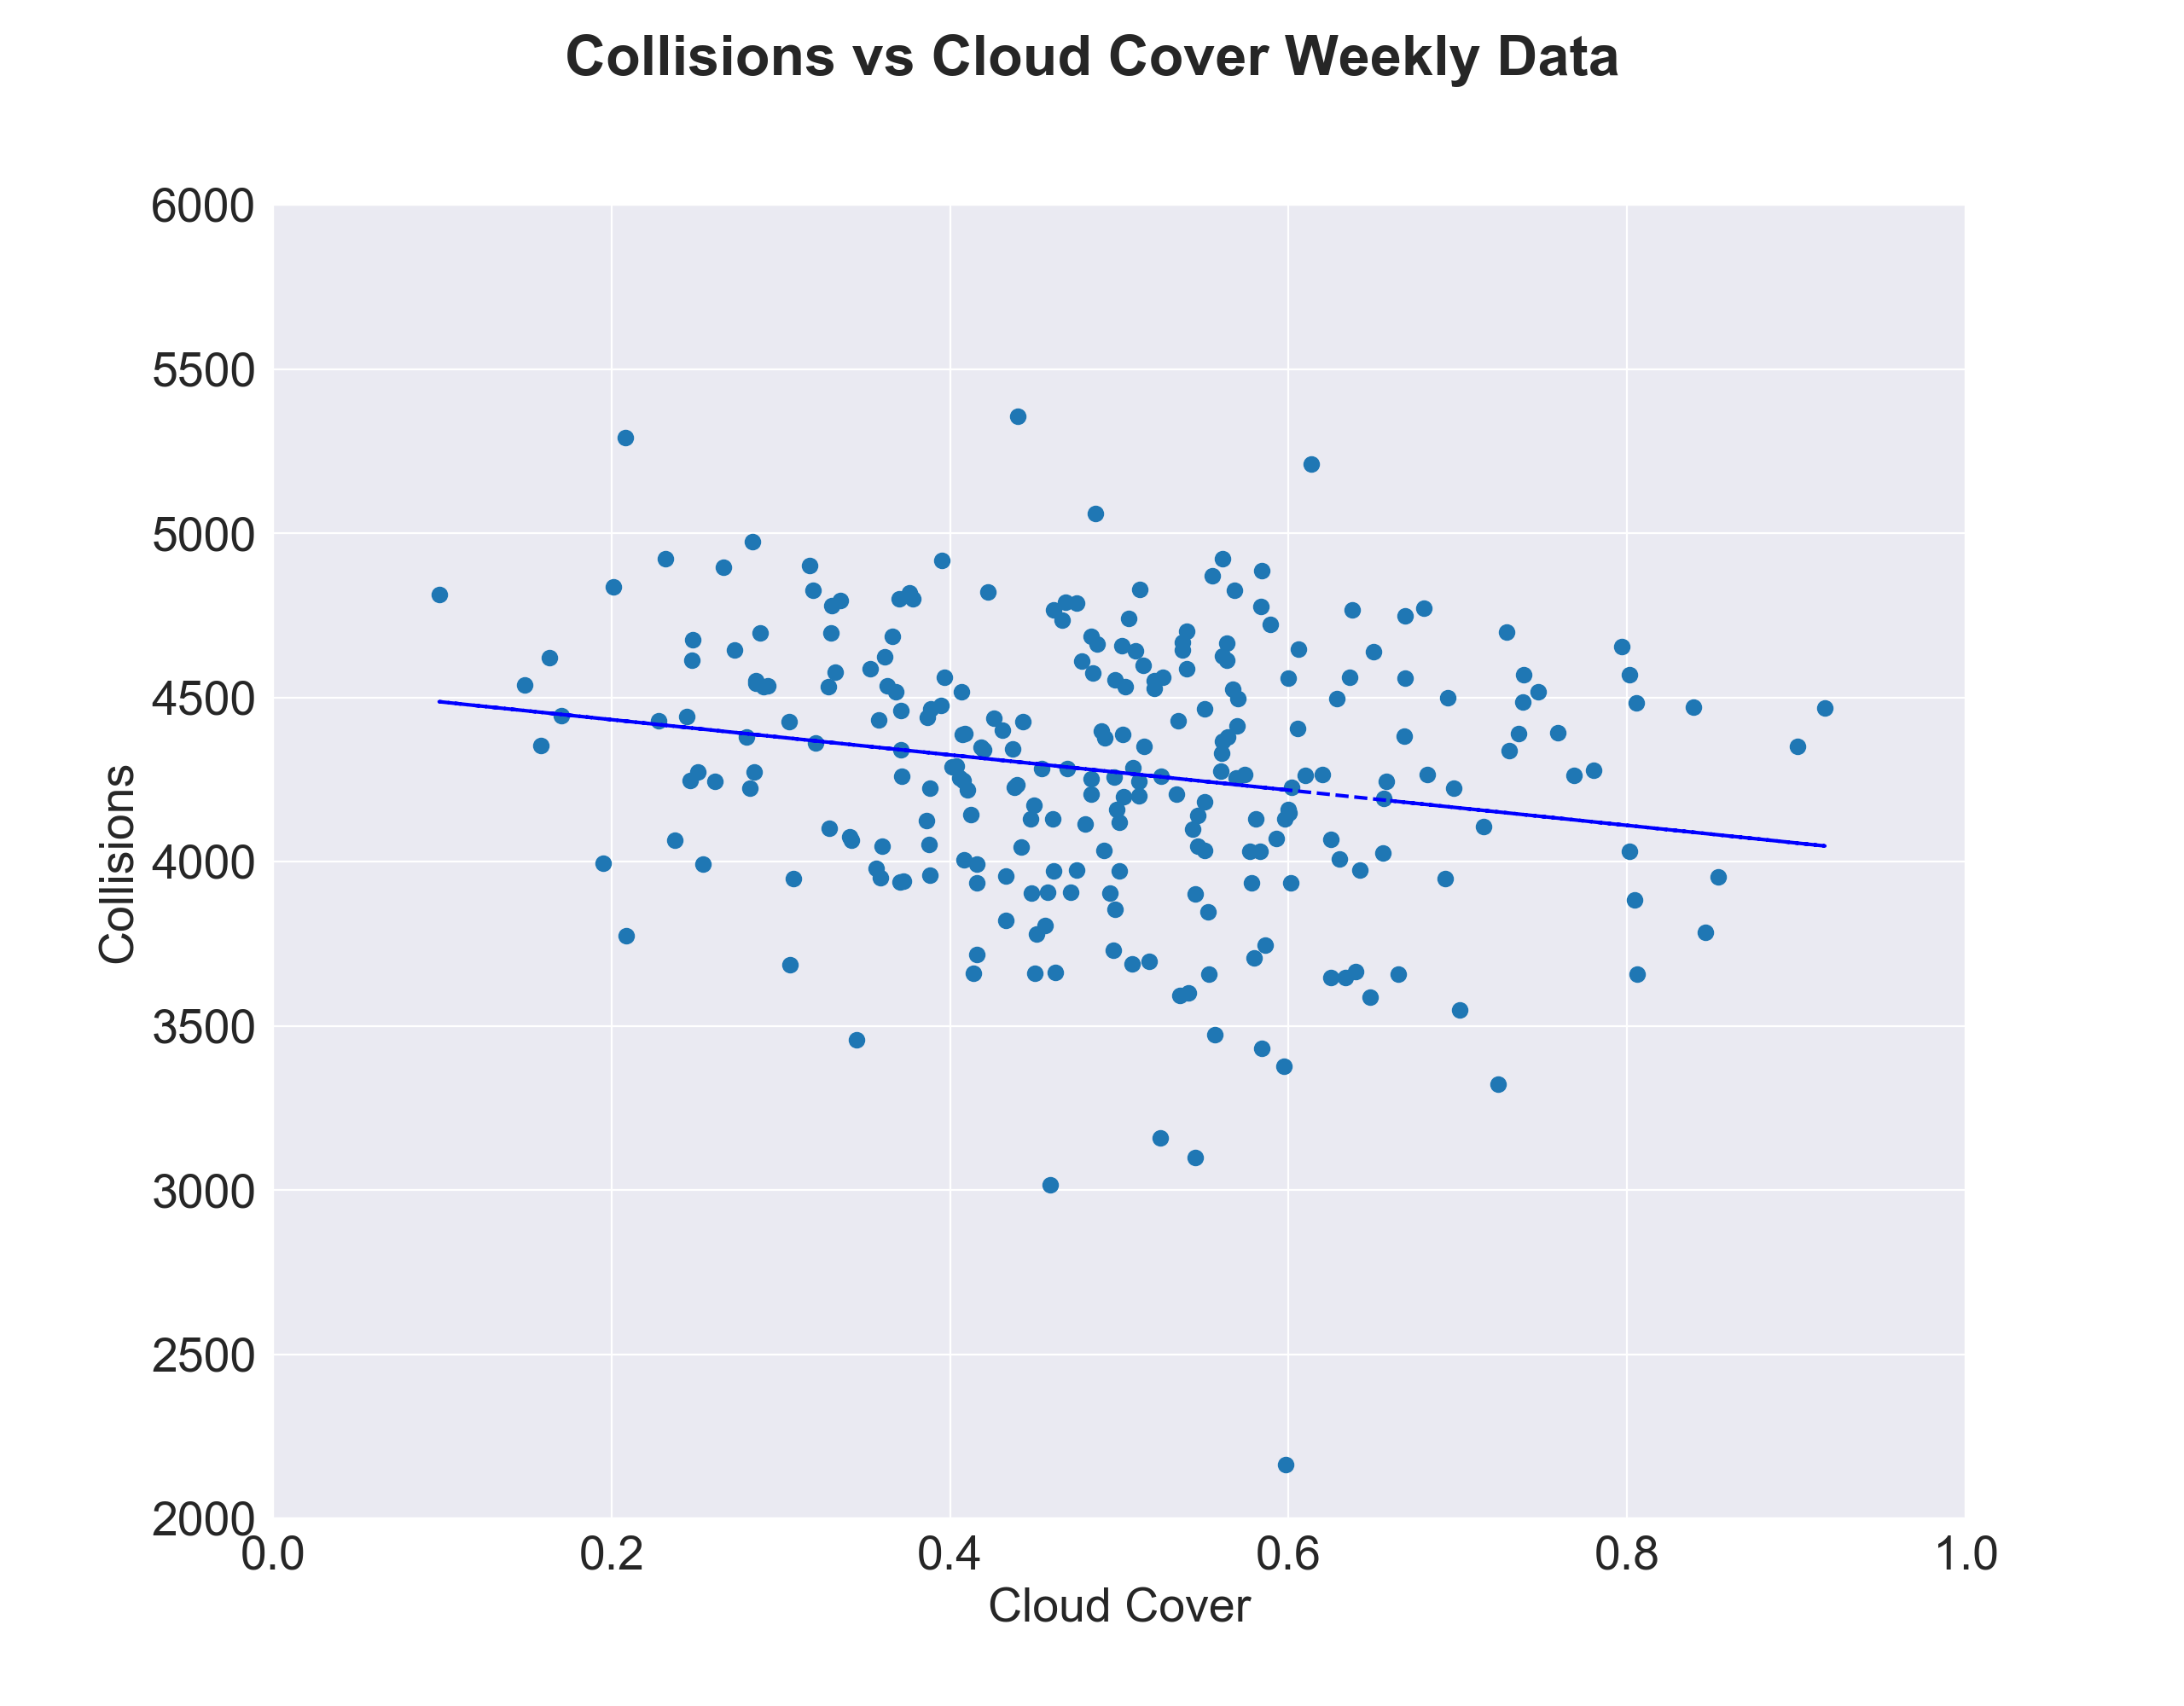

proof: regression, r value, chi square

1. **Does the minimum temperature have a significant effect on the number of Collisions, Injuries, or Deaths?**
2. **Does the wind-speed or precipitation have a significant effect on the number of collisions, injuries or deaths?**

answer using a plot that chris made

i don't know a second graph to put

proof: regression, r-value, chi square

i guess second graph could be injuries, and third could be deaths, or graph the chi square (not sure if you can do that)